YOLO Health Analyst

A cross platform application using Flutter framework which uses Dart language.

Flutter:
Complete documentation for setup: https://flutter.dev/docs/get-started/install

For Linux:
Flutter SDK: https://flutter.dev/docs/get-started/install/linux#get-the-flutter-sdk
Check for proper setup: https://flutter.dev/docs/get-started/install/linux#run-flutter-doctor
Update Path [IMP] https://flutter.dev/docs/get-started/install/linux#update-your-path
Android Studio Setup: https://flutter.dev/docs/get-started/install/linux#android-setup

Now open this project in Android Studio by cloning it.

After setting up Project, do some necessary changes:

Note: On getting Upgrade Dependencies notification option while setting up project, click on that to upgrade it.

1) Go login_page.dart as shown in pic and select ‘CountryPicker’. Now press Ctrl+B and a new file will open.
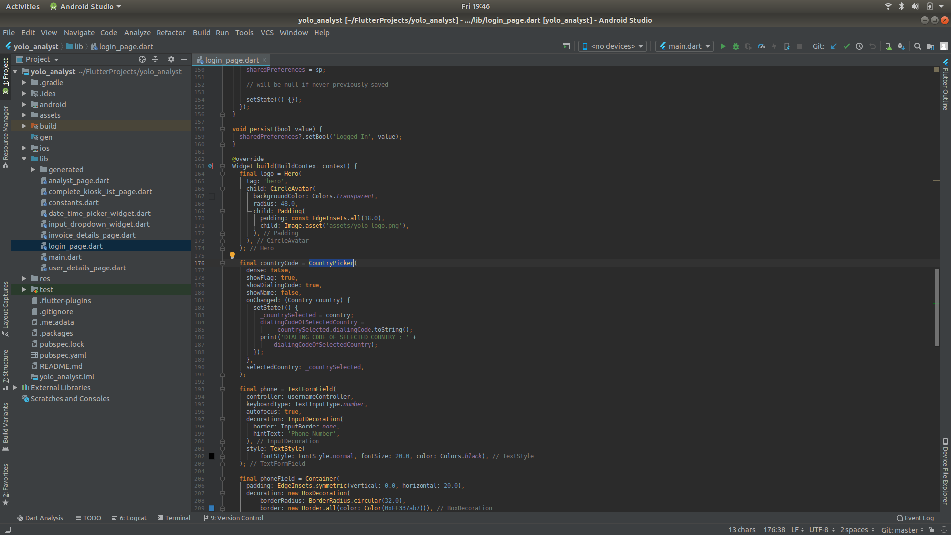
2) Change ‘displayCountry’ variable with the highlighted line in pic below.
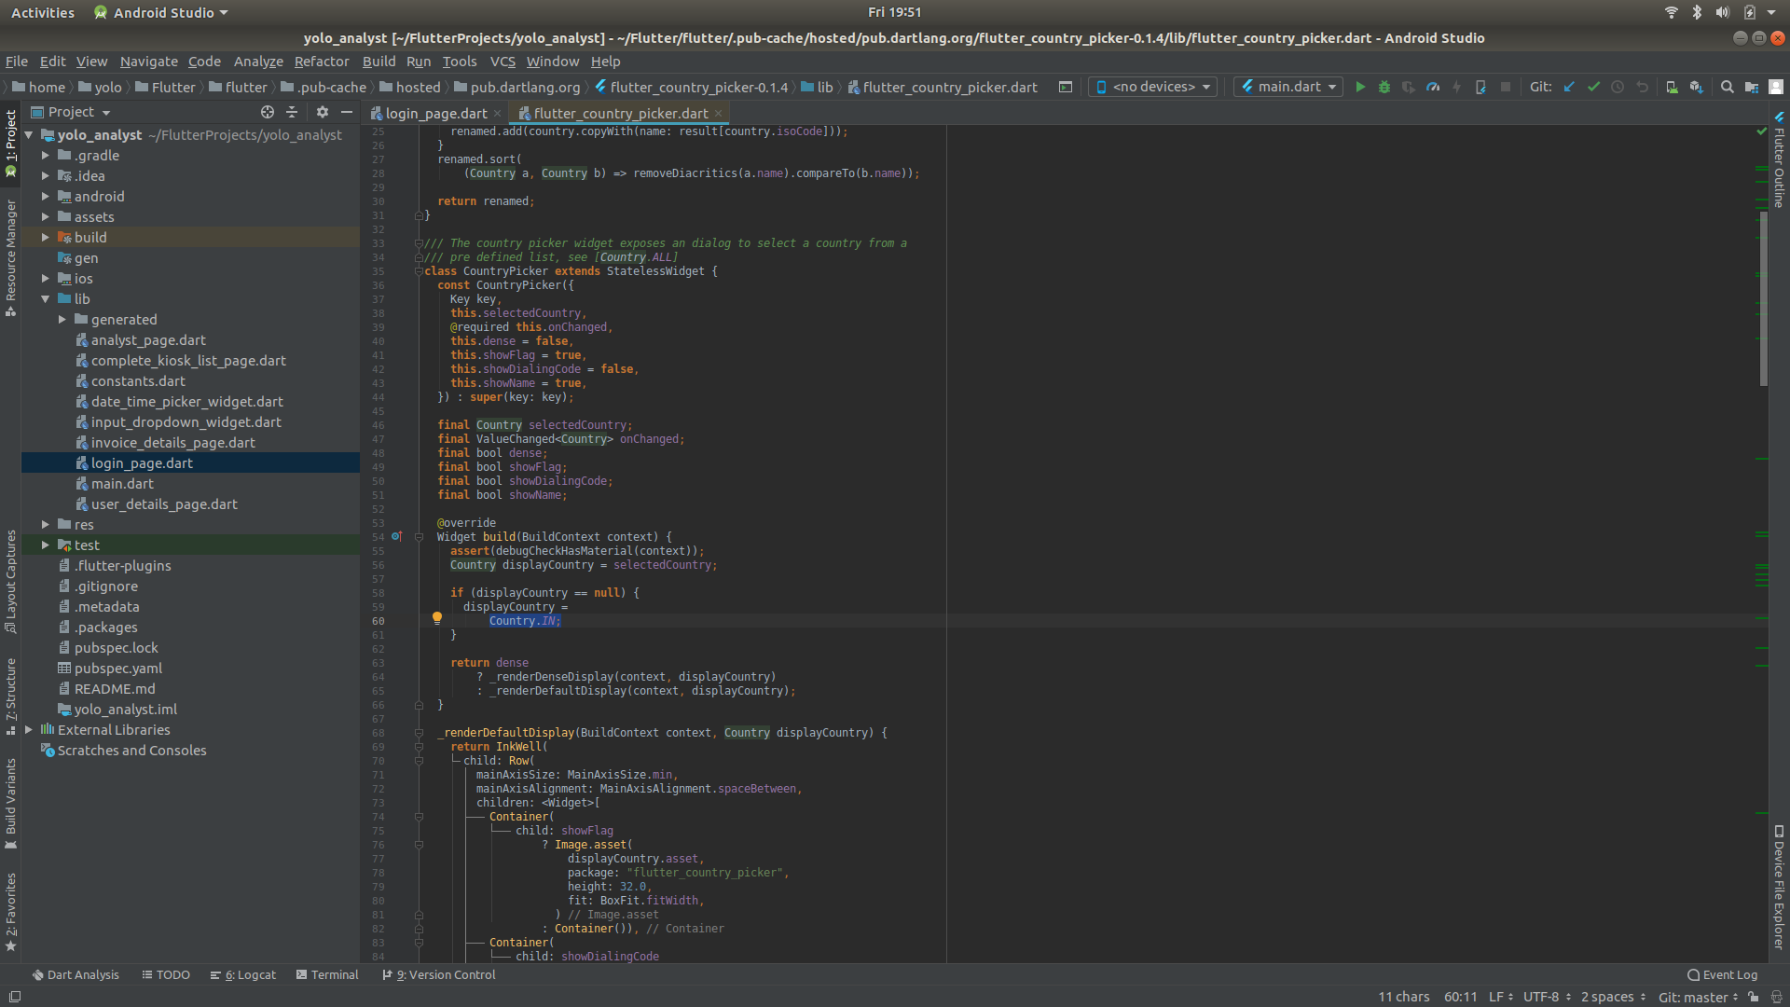
3) Run the app by clicking on Run.

Android:
Complete doc to build Android .apk file for release: https://flutter.dev/docs/deployment/android

To build .apk for testing purpose:
1) [IMP] https://flutter.dev/docs/deployment/android#reviewing-the-app-manifest
2) https://flutter.dev/docs/deployment/android#building-the-app-for-release
3) https://flutter.dev/docs/deployment/android#build-an-apk

Note: It is important to add Internet permission in AndroidManifest.xml file to work apk on Android.

Refer [IMP] https://youtu.be/qSn68_WLRKc

iPhone:
Complete doc to build .ipa file for iPhone: https://flutter.dev/docs/deployment/ios

To build .ipa for testing purpose:
1) [IMP] https://flutter.dev/docs/deployment/ios#review-xcode-project-settings
2) [IMP] https://flutter.dev/docs/deployment/ios#create-a-build-archive

Refer [IMP] : https://youtu.be/T54FEVF9QrU

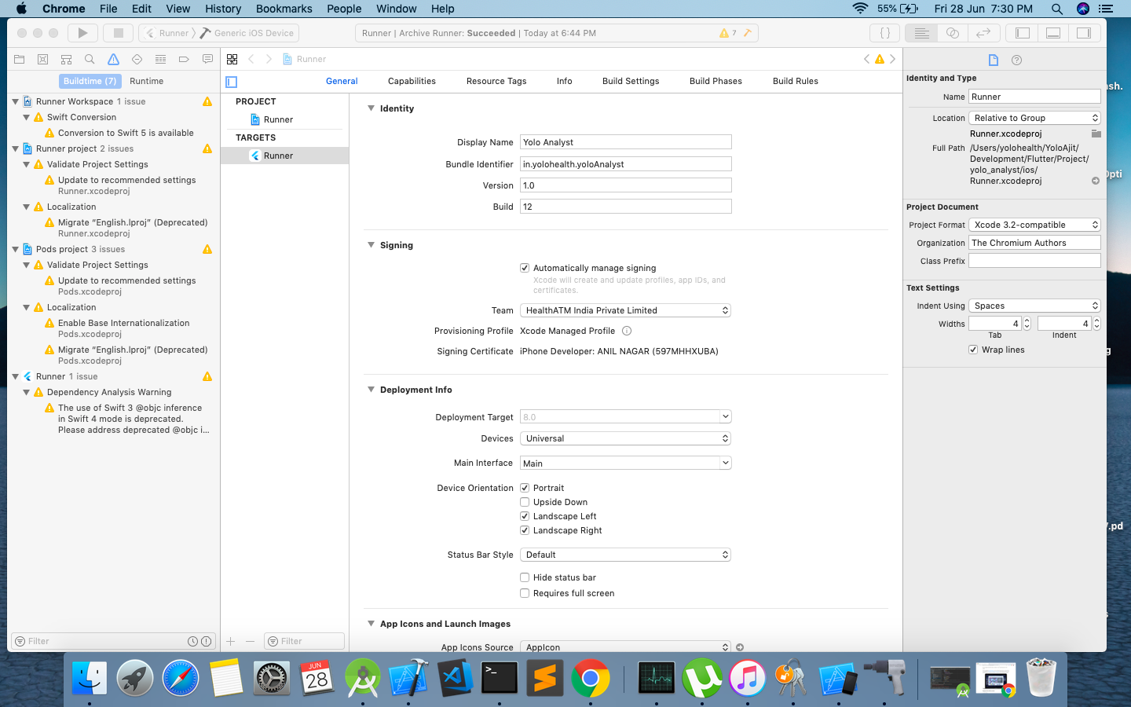

Click on Product -> Archive
and wait to get this window after successful build

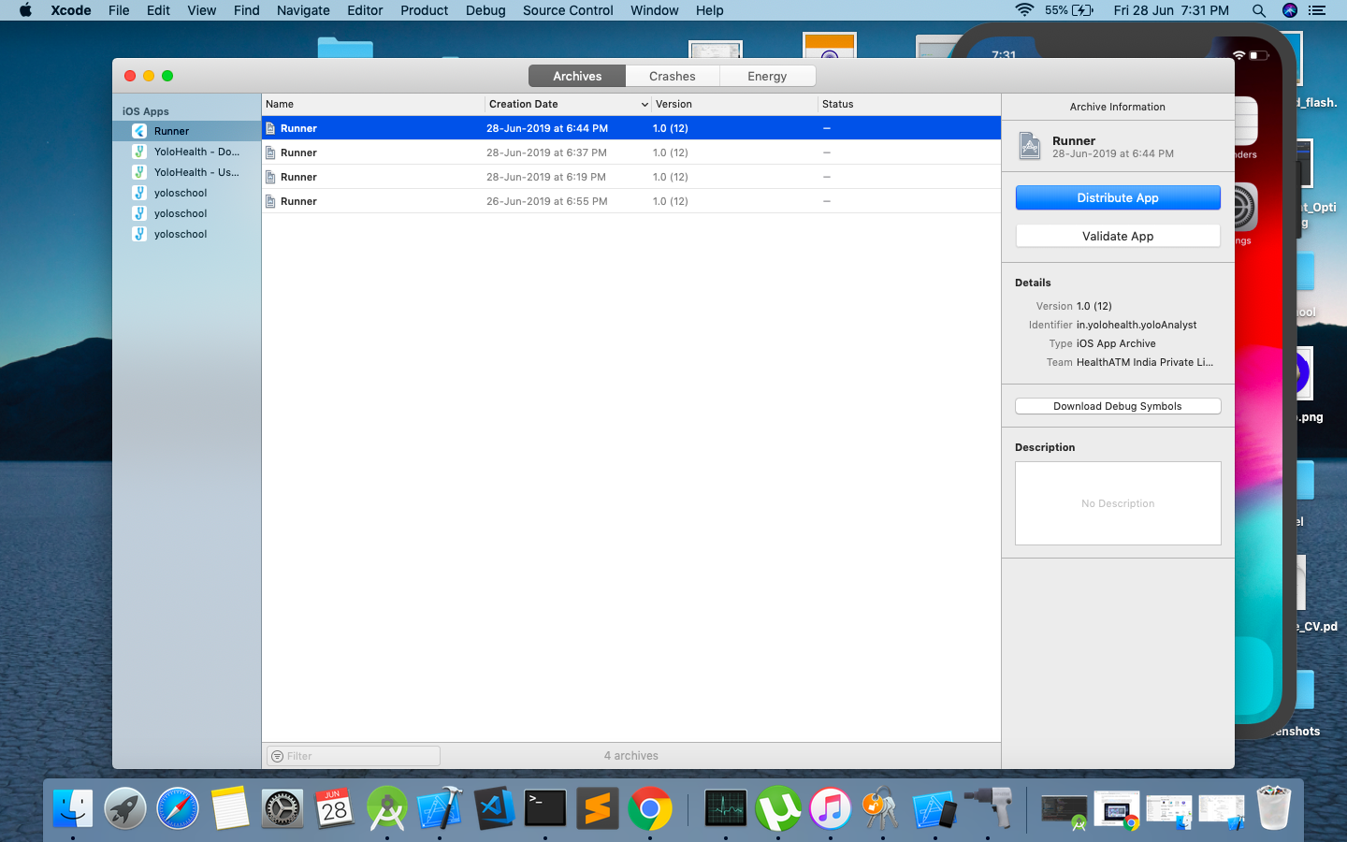
Click on Distribute App
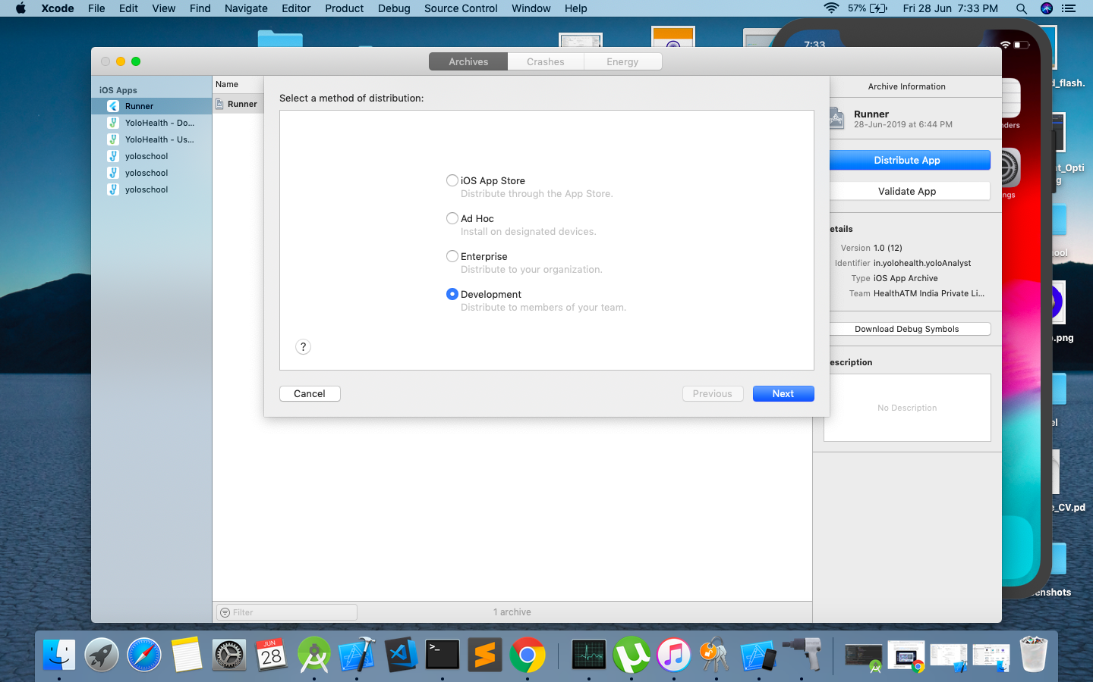
From here Do Next....
And .ipa file gets generated.

